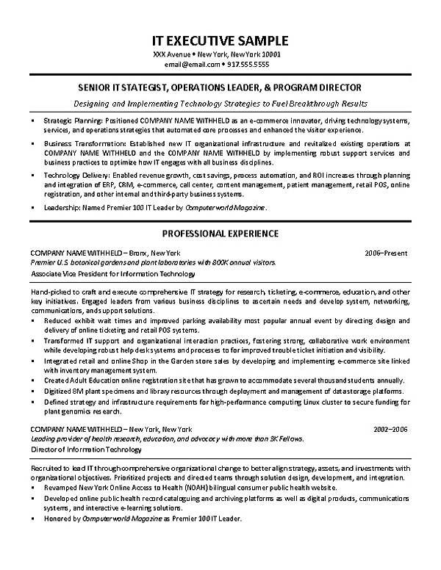
IT EXECUTIVE SAMPLE
XXX Avenue New York, New York 10001 email@email.com* 917.555.5555
SENIOR IT STATEGIST, OPERATIONS LEADER, & PROGRAM DIRECTOR
Designing and Implementing Technology Strategies to Fuel Breakthrough Results
Strategic Planning: Positioned COMPANY NAME WITHHELD as an e-commerce innovator, driving technology systems, services, and operations strategies that automated core processes and enhanced the visitar experience.
Business Transformation: Established new IT organizational infrastructure and revitalized existing operations at COMPANY NAME WITHHELD and the COMPANY NAME WITHHELD by implementing robust support services and business practices to optimize how IT engages with all business disciplines.
Techrology Delivery: Enabled revenue growth, cost savings, process automation, and ROI increases through planning and integration of ERP, CRM, e-commerce, call center, content management, patient management, retail POS, online registration, and other intemal and third-party business systems.
• Leadership: Named Premier 100 IT Leader by Computerworld Magazine.
PROFESSIONAL EXPERIENCE
COMPANY NAME WITHHELD - Bronx, New York
Premier US botonical gardens and plant laboratories with 800K annual visitors
Associate Vice President for Information Technology
2006-Present
Hand-picked to craft and execute comprehensive IT strategy for research ticketing, e-commerce, education, and other kay initiatives. Engaged leaders from various business deciplines to ascertain needs and develop system, networking, communications, andsupport solutions.
Reduced exhibit wait times and improved parking availability most popular annual event by directing design and delivery of online ticketing and retail POS systems.
Transformed IT support and organizational interaction practices, fostering strong, collaborative work environment while developing robust help desk systems and processes to for improved trouble ticket initiation and visibility. Integrated retail and online Shop in the Garden store sales by developing and implementing e-commerce site linked with inventory management system.
Created Adult Education online registration site that has grown to accommodate several thousand students annually. Digitized 8M plant specimens and library resources through deployment and management of datastorage platforms. Defined strategy and infrastructure requirements for high-performance computing Linux cluster to secure funding for plant genomics research.
COMPANY NAME WITHHELD-New York, New York
Leading provider of health research, education, and advocacy with more than 3K Fellows. Director of Information Technology
2002-2006
Recruited to lead IT through comprehensive organizational charge to better align strategy, assets, and investments with organizational objectives. Prioritized projects and directed teams through solution design, development, and integration. Revamped New York Online Access to Health (NOAH) bilingual consumer public health website.
Developed online public health record cataloguing and archiving platforms as well as digital produds, communications systems, and interactive e-learning solutions.
Honored by Computerworld Magazine as Premier 100 IT Leader.

